**Ignacio - Happiness Task 2.21**

**From Saez Lab**

Python/Psychopy version 1.90.3

My contact info:

Cell: 713-470-8673

Email: isaez@ucdavis.edu

**Setup**

1. Keypad **or** mouse

* Subjects submit a decision on each round: Left and Right arrow keys or Left and Right mouse clicks to select the Left or Right options, respectively. For happiness report they will use Left and Right arrow keys to move the cursor and Spacebar or Down arrow key to make the selection.

2. Photodiode

* Bottom left of screen.

**Scripts**

In Ignacio\Happiness_Task_v2.21

Task script: GT.py

You need to open Psychopy on the Desktop. Navigate to the correct folder and select the code. Press the Green Running man when ready. This game requires psychopy 1.90.3 – if you have a newer version (i.e. Psychopy 3.1) the game will crash – please download and run the older version here: <https://github.com/psychopy/psychopy/releases/tag/1.90.3>.

**Instructions**

In this game, patients will make choices between a safe bet or a gamble. Both safe bets and gambles can result in a win (+$), a loss (-$0) or no change ($0). Patients accumulate earnings across all trials in the task and will be paid the total final amount.

In addition to the gambling trials, they will be asked to report their subjective well-being in interleaved trials. The goal of the experiment is to assess how reward outcomes influence well-being (happiness).

There is also a baseline happiness rating at the start of the game.

**Experimenter instructions**

Start the game (GT.py), enter the subject ID. The game will also prompt for Timing (how much time the patient has to make a decision; default = 5s) and RateFreq (how often do interleaved happiness trials appear; default = 3 trials).

The game runs for 150 rounds. Remind the subject to select as fast as they can, or they will timeout. The subject can choose the safe bet or the gamble. The selected response will be highlighted while the other choices will be faded out. After a pause the relevant values will be highlighted and the payoff for this round indicated. If you select the choice that led to the best outcome you will be presented with feedback in green. If you chose the worst option feedback will be presented in red. The game lasts ~15'. Have the subject play a few practice rounds before s/he plays the game. When started, the game will ask for experimenter input you can change the timing: length for patient to respond and the frequency: how many trials between the mood task.

If needed, you can press ‘q’ to quit the experiment at any gamble. The data will be saved for the portion completed.

**Subject instructions**

In this experiment, you will play a gambling game. Each round you will have the option of choosing a safe bet or a gamble. If you select the gamble you will have a 50/50 chance at a higher or lower reward than the safe bet. After each choice you will be shown what the gamble was, and you will receive feedback on how you did for that gamble (for example, if you take the safe bet, whether you would have won had you taken the gamble). Your earnings each round are cumulative, so try to make as much money as possible.

Each time you play few trials, you will be asked to state your current happiness. Think about how the results of the last few gambles make you feel right this moment. You will move a cursor on a bar to indicate whether you are very unhappy (0), very happy (10), or feel somewhere in between. Move the cursor using the left and right arrow keys and make your selection using the spacebar or the down arrow key.

You will start by selecting how happy you are with your life in general in this moment. Then we will play a few practice rounds to make sure that you are confident you understand the game and can play it well. We can repeat the practice, so don’t worry about getting in perfect the first time around, what’s important is that you understand what’s happening and what you’re doing. Once you’re confident you got it, we will move on to the game. The game itself should take 10-12 minutes to play.

Do you have any questions before we start?

**Example screens**

**Example gamble**

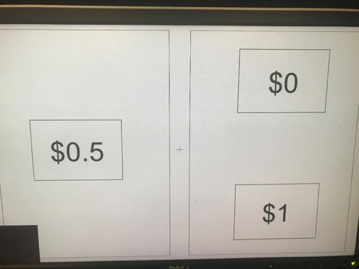

An example trial. The option on the left will result in a sure $0.5 winning. The option on the left has a 50/50 chance of leading to winning either $1 or $0.

**Safe Bet selected**

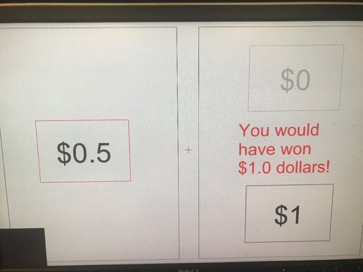

Once choice is confirmed (safebet in this case), a feedback window highlighting the relevant values. If the participant made an optimal choice, it will be highlighted in green. If their choice was not optimal it will be highlighted in red. If relevant, counterfactual gamble value (i.e. what they would have won had they taken the other option) will be highlighted in purple.

**Happiness ratings**After a variable number of trials (default = 3) a happiness rating will appear

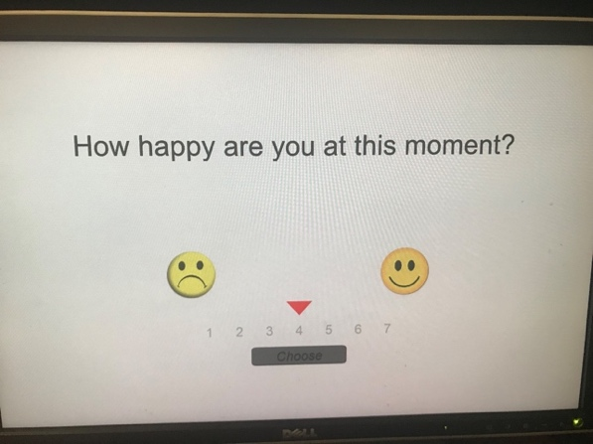

Patients will need to state how happy they feel at that very moment. This has no time limit, when they decide they will press spacebar or arrow down.